SQL Cheat Sheet
NULL
WHERE condition can be
SELECT col1, col2 FROM tablename
WHERE colname IS NULL
SELECT col1, col2 FROM tablename
WHERE colname IS NOT NULL
WHERE and ORDER BY
SELECT col1, col2 FROM tablename
WHERE condition
ORDER BY colname
SELECT col1, col2 FROM tablename
WHERE condition
ORDER BY colname DESC

Using parentheses
SELECT col1,col2 FROM tablename
WHERE
(condition1 AND/OR condition2)
OR
condition

Aggregation

SUM, COUNT, AVG, MIN, MAX
SELECT AGG(colname) AS Displayname FROM tablename

We cannot use aggregation operations when selecting multiple columns. It will throw an error. The non-aggregated column should be in GROUP BY clause.

Strings

SELECT LEN(colname) AS Displayname FROM tablename

SELECT LEFT(colname,no.ofcharacters) AS Displayname FROM tablename

SELECT RIGHT(colname,no.ofcharacters) AS Displayname FROM tablename

substring
SELECT SUBSTRING(string/colname,start,lenght)

FROM tablename
SELECT
CHARINDEX('substring',string/colname)

FROM tablename

CHARINDEX returns the position of string.

SELECT
Retrieve all rows from the table
SELECT * FROM tablename
SELECT * is not recommended.
Retrieve limited no. of rows from the table
SELECT TOP 5 * FROM tablename
Or
SELECT * FROM tablename
LIMIT 1
Or
SELECT TOP (50) PERCENT * FROM tablename
Retrieve specific columns from the table
SELECT col1,col2 FROM tablename
Retrieve unique rows from table
SELECT DISTINCT colname FROM tablename
ORDER BY
We can order by ASC, DESC. ORDER BY comes only at the end of the query.
ASC is default.
SELECT col1, col2
FROM tablename
ORDER BY colname
DESC
SELECT col1, col2
FROM tablename
ORDER BY colname DESC
WHERE
SELECT col1, col2 FROM tablename
WHERE condition
SELECT col1, col2 FROM tablename
WHERE colname BETWEEN val1 AND val2
Operators
= Equal
> Greater than
< Less than
>= Greater than or equal to
<= Less than or equal to
<> or != not equal to
Logical Operators
AND
OR
NOT
OUTER JOIN
It just grabs all the rows from the columns that are matched. It is symmetrical.
SELECT table1.colname, table2.colname
FROM table1
FULL OUTER JOIN table2
ON table1.matchingcolumn = table2.matchingcolumn
LEFT JOIN

A LEFT JOIN will return ALL rows in the left table, and any matching rows in the right table. If there aren't any matches in the right table for a particular row, then a NULL is returned. It is not symmetrical.
SELECT table1.colname, table2.colname
FROM table1
LEFT OUTER JOIN table2
ON table1.matchingcolumn = table2.matchingcolumn
RIGHT JOIN
Just the opposite of LEFT JOIN.
SELECT table1.colname, table2.colname
FROM table1
RIGHT OUTER JOIN table2
ON table1.matchingcolumn = table2.matchingcolumn
UNION
(SELECT column_name(s) FROM table1)
UNION
(SELECT column_name(s) FROM table2);
Note: UNION works for tables with similar structure.
Ex: Sales report for different quarters.
SUBQUERY
A sub query allows you to construct complex queries, essentially performing a query on the results of another query.
SELECT col1, col2
FROM tablename
WHERE condition
(SELECT colname(s) FROM tablename)
CREATE
CREATE TABLE tablename(
colname TYPE CONSTRAINT,
colname TYPE CONSTRAINT
)
INSERT
INSERT INTO tablename (colname1, colname2, . .)
VALUES
(value1,value2,. . )

UPDATE
UPDATE tablename
SET colname = value
WHERE condition;

GROUP BY AND HAVING
GROUP BY groups the table based on a cateogory and then an aggregate funtion can be applied.
SELECT category_column, AGG(data_column)
FROM tablename
GROUP BY category_column

SELECT category_column, AGG(data_column)
FROM tablename
WHERE condition
GROUP BY category_column

Note: Here WHERE should not refer to an aggregate column.

SELECT category_column, AGG(data_column)
FROM tablename
WHERE condition
GROUP BY category_column
ORDER BY column_name

WHERE clause is used to filter rows before any grouping occurs. HAVING clause is used for filtering rows after grouping operation.

SELECT category_column, AGG(data_column)
FROM tablename
GROUP BY category_column
HAVING condition
ORDER BY column_name
JOINS
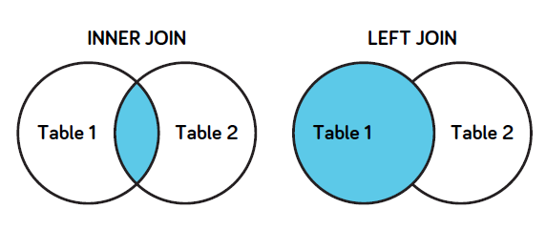
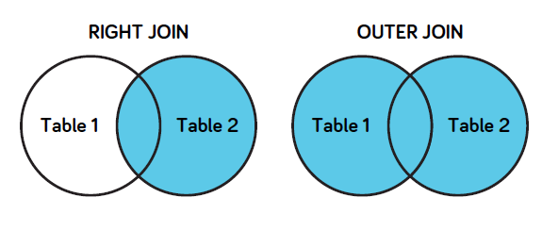
INNER JOIN
The result will contain the set of records that match in both tables. It will ignore the records that does not match. It is symmetrical join. The table position does not matter.

SELECT table1.colname, table2.colname
FROM table1
JOIN table2
ON table1.matchingcolumn = table2.matchingcolumn

DELTE TABLE
DROP table tablename;
ALTER TABLE
ALTER TABLE tablename
ADD colname TYPE
ALTER TABLE tablename
DROP COLUMN colname
VARIABLES
DECLARE @varname TYPE
SET @varname = VALUE

